Decide which answer A, B, C or D best fits in each space. KEY: SEE PAGE 2
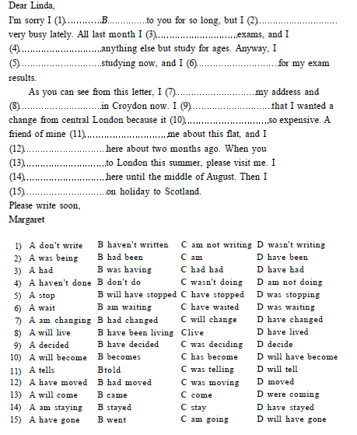

KEY:
